INVITATION

Dear President,

On behalf of the Organizing Committee and the CROATIAN ARCHERY ASSOCIATION, I'm pleased to invite and welcome your Association to participate to the Second and Final leg of the 'EUROPEAN YOUTH CUP 2017.' competition that will be held in Porec/Croatia, on 9-14 July 2017.
This event will be organized following the WA ARCHERY and WAE YOUTH CUP RULES for Junior Women, Junior Men, Cadet Women and Cadet Men classes, Recurve and Compound divisions in the Outdoor Target Archery discipline.

Hereby you will find enclosed all the necessary documents concerning the registration, organization and participation in this event.

We kindly ask you for your response within the stated deadlines:

Preliminary Entries 10 April 2017
Preliminary Hotel Reservation Form 10 April 2017
Visa Invitation Letter Form 10 April 2017
Final Hotel Reservation Form 19 June 2017
Transportation Form 19 June 2017
Budget Form 19 June 2017
Final Entries 19 June 2017

I am looking forward to welcoming you in Porec, Croatia.

Yours sincerely,

Mr. Darko Uidl

Croatian Archery Association
OC
President

PRELIMINARY PROGRAMME

Saturday |  |  | 8 July 2017 | Arrival of Delegations  Practice field and local transportation available
Sunday | Day 1 |  | 9 July 2017 | Opening Ceremony  Official practice and Equipment inspection  Team Managers Meeting
Monday | Day 2 |  | 10 July 2017 | Qualification round CADETS + 1/48 and 1/24 Elim. Round  Qualification round JUNIORS + 1/48 and 1/24 Elim. Round
Tuesday | Day 3 |  | 11 July 2017 | Mixed Teams Eliminations  Mixed Teams Medal Matches  Award Ceremony
Wednesday | Day 4 |  | 12 July 2017 | Individual Eliminations - Up to ½ Finals
Thursday | Day 5 |  | 13 July 2017 | Team Eliminations  Team Medal Matches  Award Ceremony
Friday | Day 6 |  | 14 July 2017 | Individual Bronze and Gold Medal Matches  Award Ceremony
Saturday |  |  | 15 July 2017 | Departure of Delegations

Note
This preliminary program could be changed slightly according to the number of participants.
All changes will be published and distributed to all participants in good time.

PRELIMINARY & FINAL REGISTRATION

No entry forms will be available for registering for this event. The registration process should be done using the World Archery Online Registration System (WAREOS).
The number of athletes that may be entered by a Member Association is limited to four (4) in each category.
All World Archery MA’s are eligible to compete in European Youth Cup competitions, but only the results of the athletes from WORLD ARCHERY EUROPE MA’s will be taken in consideration for the Youth Cup Circuit.
In order to use WAREOS, please enter this address in your internet browser http://register.worldarchery.org and use the Username and Password that World Archery has assigned to your Member Association. After entering the WAREOS, please go to 'Online Registration' and register your archers for this event. Pay attention: the date of birth is mandatory.
A “WAREOS User Manual” can be downloaded in PDF format from the same website.
For any question regarding WAREOS, please contact Mr. Matteo Pisani at matteo@pisani.eu.

Starting date of online-registration with WAREOS is: | 1 February 2017
End of Preliminary registration: | 10 April 2017
End of Final registration: | 19 June 2017

Please pay attention to the stated deadlines. After passing the deadlines, MAs would not be able to enter or update their data in WAREOS anymore, as the system will be blocked. In this case, if any MA would like to change or proceed with the Final Registration process or change their Final entry, it is required to contact Mr. Matteo Pisani at email: matteo@pisani.eu with a copy to Organizing Committee email: archery@archery.hr.

The Member Associations that will enter in WAREOS after 19 June 2017 (Final Registration deadline) will pay a penalty of € 100 per athlete to be paid to the OC on arrival for the tournament.

The Member Association with Final registration in WAREOS that will differ by more than 4 athletes from the preliminary registration, will have a penalty fee of € 100 to be paid to the OC upon arrival at the event.

A Member Association that has made Final entry in WAREOS and does not participate will be invoiced for the number of entries entered in the system, unless the Member Association has informed the OC and Matteo Pisani in writing at least one week prior to the event that they are unable to attend.

Only after having paid the penalty fees to the OC, a Member Association can register the athletes in order to participate in the competition.

Since entries will be made through WAREOS only, MA’s declare that their athletes and officials are aware of the participation waiver and anti-doping agreement, and we recommend MA’s to advise their athletes on this matter. However, accepting the conditions of the athlete participation waiver and anti-doping agreement are an eligibility requirement to participate in the event.

As a final note, only member Associations in good standing will be eligible to compete. This means that World Archery fee 2017 must have been paid prior to participation.

ACCOMMODATION & GENERAL INFORMATION

There will be several official hotels available. All Hotels are 3* or 4* star category.

HOTEL | Category | Single room  Price per room per night | Double room  Price per person per night
LAGUNA ISTRA / GRAN VISTA | 3* | € 100 | € 85
LAGUNA MOLINDRIO | 4* | € 125 | € 110

LAGUNA ISTRA / GRAN VISTA:

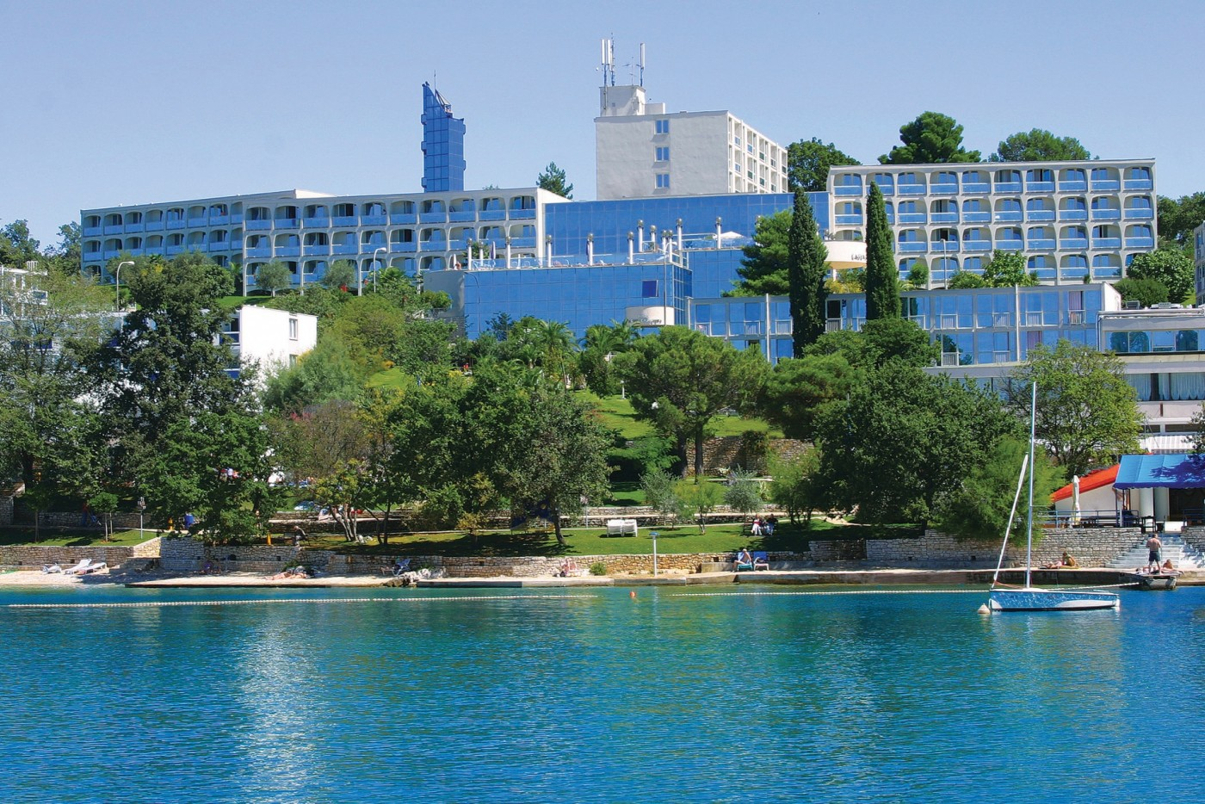
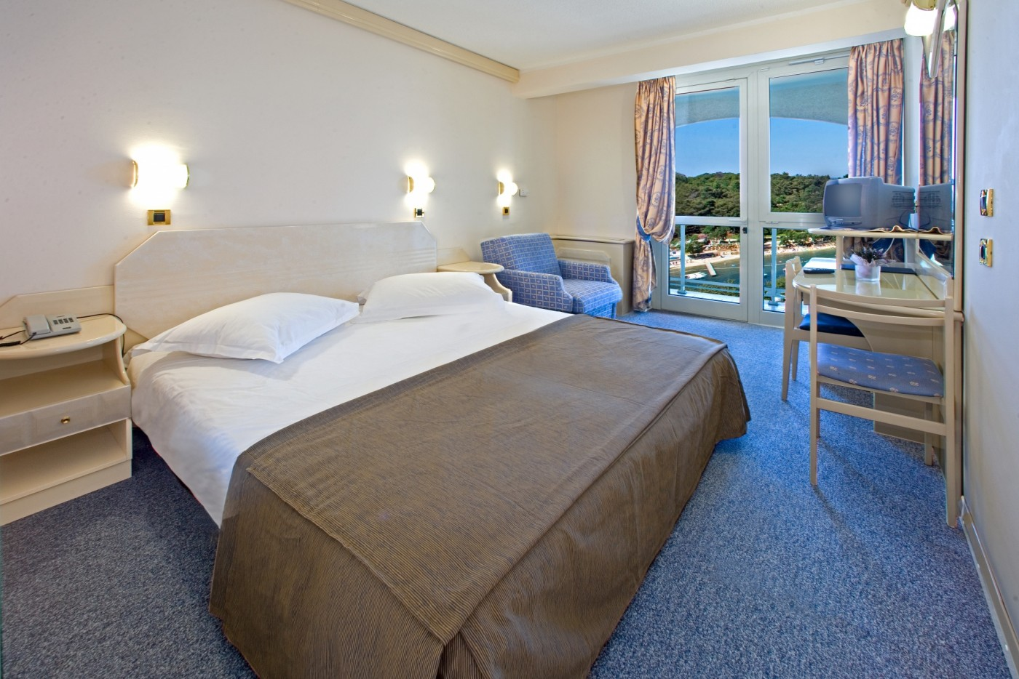
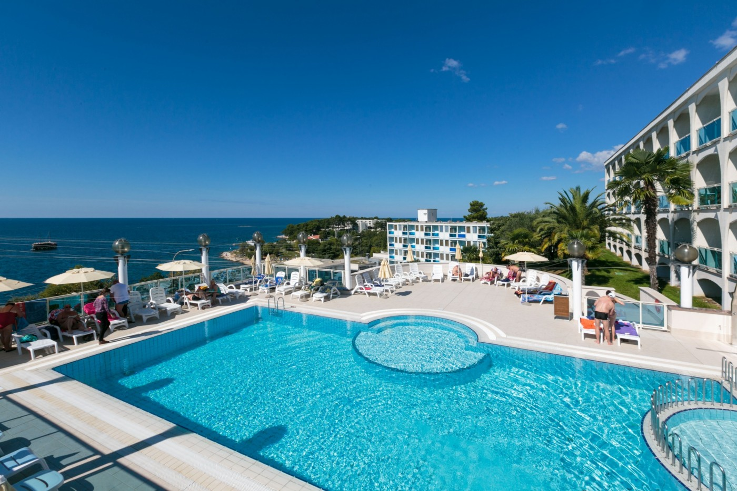

LAGUNA MOLINDRIO:

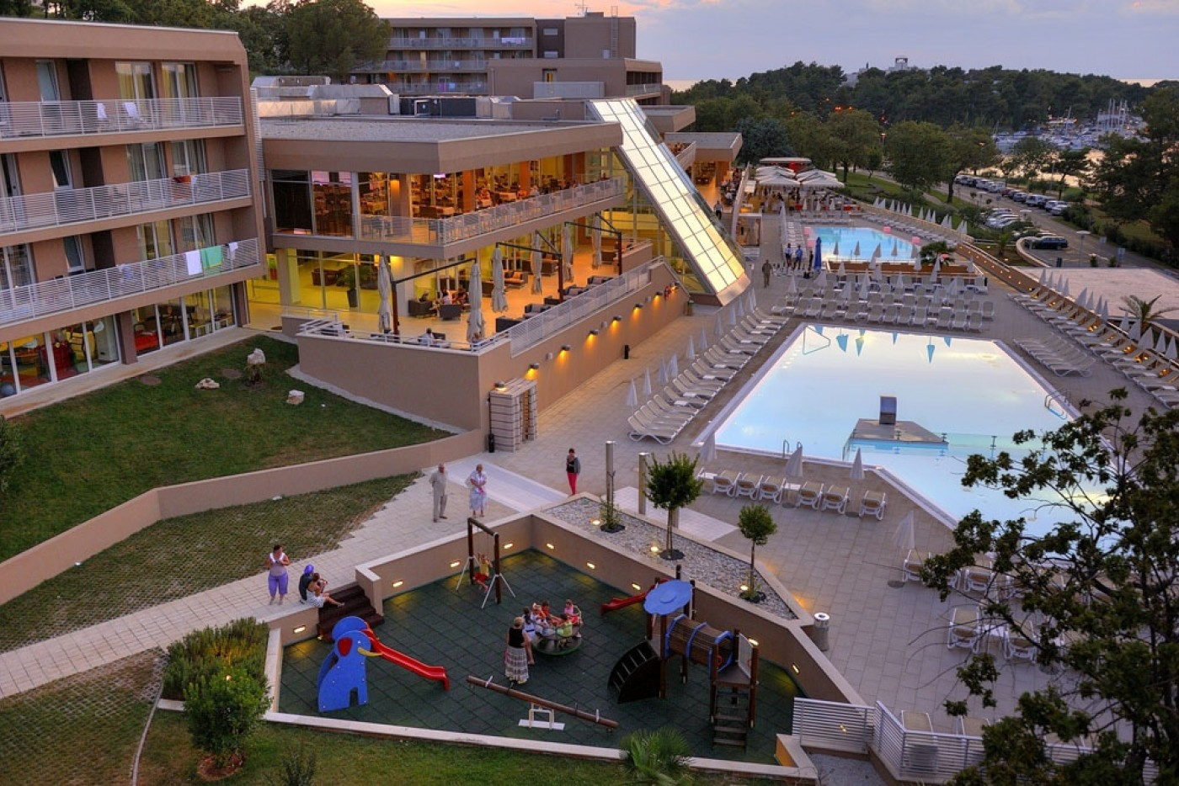
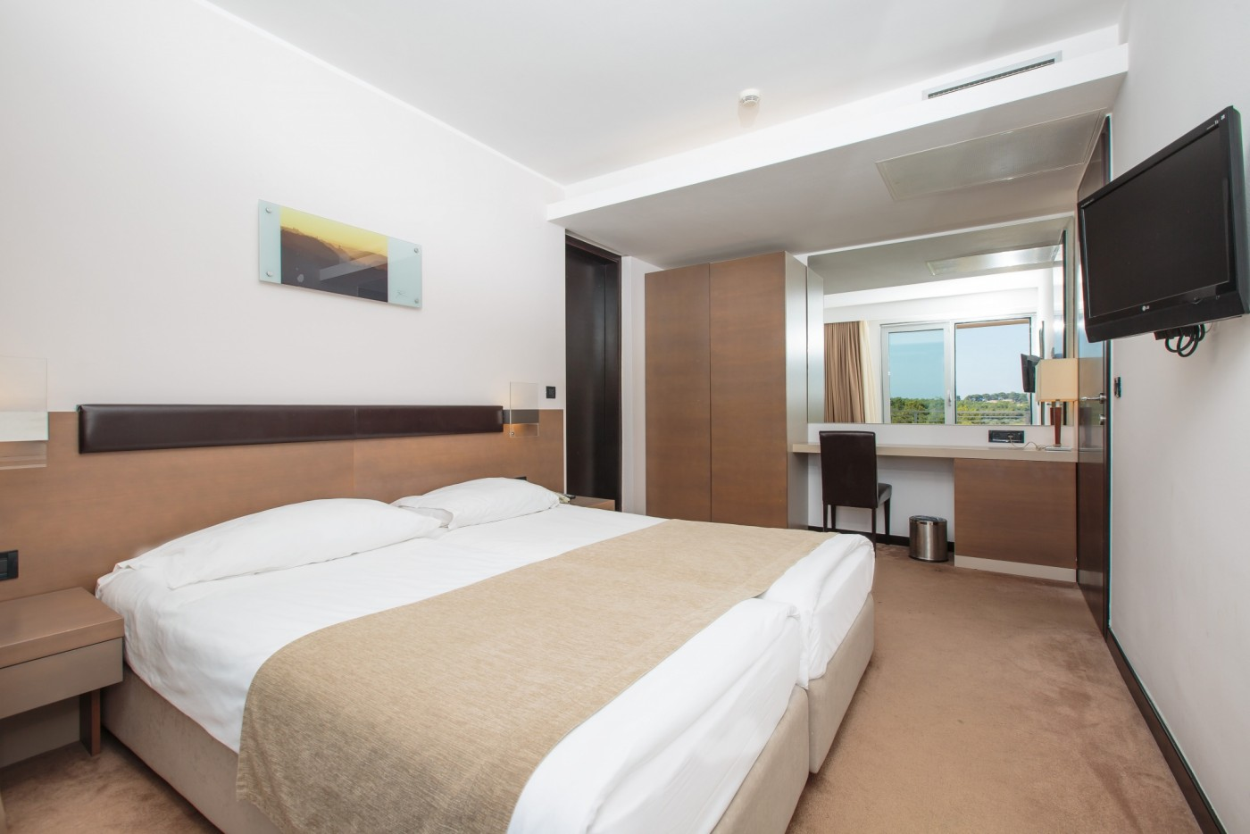
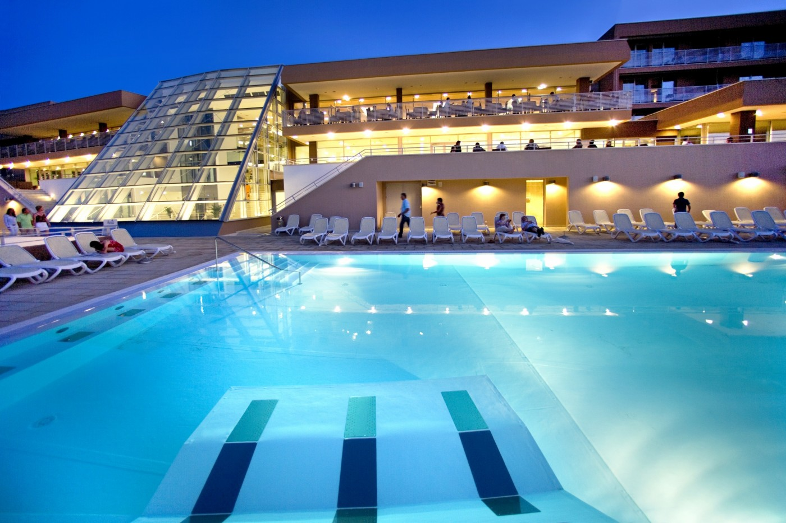

The room prices are in Euro (€) per person and per night.
It is offered on a 'Full Board' basis, including bed, breakfast, lunch and dinner.

In the room price is also included service charge and VAT and the local transportation from/to Hotel/Venue, with a daily shuttle service to the competition.

Free Wi-Fi will be available at the hotel reception area and hotel rooms.

Preliminary Hotel Reservations should be made before 10 April 2017.
Reservations after this date shall be subject to availability.

Final Hotel Reservations should be made before 19 June 2017.

A 50% deposit of the Accommodation payment is required before 10 April 2017.

The rest 50% of Accommodation payment is to be made before 19 June 2017.

Please note that Hotel Reservations will be made in priority of receiving the 50% payment of Accommodation payment, no later than 10 April 2017.

Accommodation cannot be guaranteed, nor at the above quoted prices beyond each deadline.
Reservations after each deadline will be considered only according to availability and the room rate may change.

For receiving the best check in service upon your team arrival at the hotel, you are requested to send to the OC a list with the roommates’ names for every room you have reserved (see page 11. Accomodation table - Rooming list).

The rooming list should be sent no later than 22 June 2017.

Note
Please refer to the Accommodation pages below for detailed hotel information. Ensure that you complete all the necessary forms by the specified date and make full payment for the accommodation at the time of booking.
See detailed payment instructions below.

The Organizing Committee reserves the right to accommodate you athletes, according to hotel occupancies, in order of requests’ arrival.
The Organizing Committee reserves the right to accommodate your athletes in equal characteristics if necessary.

To improve the speed of serving rooms, is asked to send in addition to be preferred hotel also named occupants of every room accommodation - single and double.

Participants who will decide to book their accommodation in other hotels (non-official hotel) should pay a DOUBLE ENTRY FEE and the OC will not be responsible to provide transportation from that Hotel to the venue (transport for these teams will be provided only to and from airport). Also, it is not possible to distribute any information on the non-official hotels.

ADDITIONAL INFORMATION

Entry fees
Individual: 75 € per athlete
Officials: Free
Teams: Free
*The Entry fee includes the daily local transportation Hotel-Venue.

Transportation
Zagreb International Airport (ZAG)
From/to Airport – Hotel (arrival and departure) 50 €/person
Local transportation will be available between hotel and competition venues. Exact transportation timetables will be confirmed. Buses and/or vans will be used.

Arrival and departure from the Trieste airport (TRS) is under a special agreement and prices. Please announce to the OC (archery@archery.hr) arrivals and departures to this airport.
Due to the seasonal traffic congestion at border crossings, OC cannot guarantee transportation schedules, so please use the Zagreb Airport (ZAG) for arrivals and departures.

Closing Party
After the dinner on 14 July 2017, a Closing disco party will be organized in the hotel nearby.
Opening: 20:30 p.m. until the end.
Participation in this event is € 15 per person. Two drinks are included (voucher).

Water
Water will be available on the fields free of charge.

Visa
For all nations that will need Visa permits, please make sure to apply for, such as early as possible in your country of origin before leaving. If our help is needed you may contact us immediately: archery@archery.hr, no later than 10 April 2017 for an official invitation over to the Croatian Embassy for further cooperation.
Visa Invitation Letter (VERY IMPORTANT):
To make an official invitation we'll need a real size photo and Passport scan from every team member.
The visa application fee (in the Croatian Consulates or Embassies in your country) should be covered by the participant.
Instead of the traditional invitation letter in the Croatian Embassy or Consulate in your country you will be required to show the “case number” for the whole team that we will send you in 10 days after we receive your documents. Please fill in the Visa Invitation Letter Form as soon as possible and send it with passport copies to archery@archery.hr

Dress Regulations
WA & WAE dress regulations do apply.

Prepayments
Hotel booking will only be regarded valid as soon as a 50 % down payment has been received by the Organizing Committee before 10 April 2017.
The balance of full payments is to be made before 19 June 2017.

Booking non-official hotel
Participants who may decide to book their accommodation at or with other hotels, i.e. non-official hotels and not through the Organizing Committee (OC), shall have to pay a DOUBLE ENTRY FEE, and the OC will not be responsible for providing transportation from those hotels to the venue (transport for these teams will be provided only to and from airport). It is not possible to distribute any information on the non-official hotels.

Meals at the venue
All meals will be served at the Hotel, during the official days.
For replacing lunch with lunch-box, please inform the Hotel reception desk one day before.

Weather
In July, you can expect in Porec the temperature 30-35°C with around ten hours of sunshine per day. Nights can be 20–25°C.
Most of the time it is sunny, but we suggest you to have some piece of rain clothes. The rainy day is unusual at this time of the year.

Accreditation and Team Managers Meeting
Accreditation will take place upon arrival at the OC head office.
More details will be provided at the Team Managers Meeting.

OC contacts
Phone for assistance when traveling
24 hours English
Mr. Kresimir Cadez
Mobile: +385 91 4343 463
E-mail: archery@archery.hr

For all matters
24 hours English
Mrs. Andrea Vrbik
Mobile: +385 99 6948 662
E-mail: nea1370@hotmail.com

Please also refer to the detailed Payment Policy below.

PAYMENT POLICY

For the payment of the Accommodation 50% deposit is required before 10 April 2017.
A balance Invoice will be issued after payment.
The Entry Fees should be paid in full before 10 May 2017.
The Transportation Fee should be paid in full before 19 June 2017.
The balance of full payments is due by 19 June 2017.
An Invoice will be issued after full payment.
All prices for payments after the stated deadlines are subject to additional charges.

BANK INFORMATION for ACCOMMODATION, TRANSPORTATION AND ENTRY FEE:

Bank Name: PRIVREDNA BANKA ZAGREB
Address: Dubrava 39, Zagreb, CROATIA
Account Name: STRELICARSKI TRENING CENTAR doo
Account Number: 1110469072
SWIFT: PBZGHR2X
IBAN: HR1423400091110469072

NOTE: ALL PAYMENTS SHOULD BE IN EURO (€)
BY BANK TRANSFER, for a 50% of the Accommodation payment before 10 April 2017.
BY BANK TRANSFER (for the balance of full payments) before 19 June 2017.

Bank transfer fees are the responsibility of the sender.

NO CREDIT CARDS, NO TRAVELLERS CHEQUES, NO FOREIGN CURRENCIES

Cancellations & Changes
Cancellation must be in writing by email to archery@archery.hr and Matteo Pisani (matteo@pisani.eu)
The following conditions will apply:
- Cancellation received before and included 10 April 2017 for full refund of the deposit
- Cancellation received between and included 10 April 2017 and 19. June 2017 for 50% refund of the deposit
- Cancellation received after 19. June 2017. There will be no refund of the deposit payment.

All rates for payments after deadlines are subject to additional charges without prior notice.
All refunds, if any, will be processed after the event.
Name change (the same category and division) will be accepted up to 72 hours before the event without any additional charge.

OC should be informed about changes in the travel program 72 hours' prior arrival. If your arrival is later than your original schedule, the room charges are starting from the original date indicated by the Member Association in their Accommodation form.

OC Contact
Name: Mr. Cadez Kresimir
GSM: +385 91 4343 463
Email: archery@archery.hr
Language: Croatian and English
Official website: www.archery.hr

PRELIMINARY HOTEL RESERVATION FORM
Return at the latest 10 April 2017

Member Association: ________________________________________

Email address: ___________________________

Telephone: ___________________

Hotel Name:

HOTEL LAGUNA ISTRA / GRAN VISTA 3*

HOTEL LAGUNA MOLINDRIO 4*

Arrival Date: ________

Departure Date: ________

Number of Nights: ________

Number of Rooms

Single:
Double:

Please check this box if you need facilities for persons with disabilities.

We require that 50% of the accommodation payment should be made before 10 April 2017.

Date: ______________ Signature President / Secretary General

Please return the Preliminary Hotel Reservation Form to: Croatian Archery Association
Before 10 April 2017
E-mail: archery@archery.hr

TRANSPORTATION FORM
Return at the latest 19 June 2017

Member Association: ________________________________________

Email address: ___________________________

Telephone: ___________________

Total number of Persons: |  | x 50 € = | TOTAL (B): €

Arrival information
By plane:
Airport: Zagreb International (ZAG) Flight No: ______________

Date: ______________ Arrival Time: ______________

Departure information
By plane:
Airport: Zagreb International (ZAG) Flight No: ______________

Date: ______________ Departure Time: ______________

Please check this box if you need facilities for persons with disabilities.

Date: ______________ Signature President / Secretary General

Please enter the team managers mobile phone number __________________________ which will serve for assistance in case of possible needs.

Note:
OC should be informed in writing about changes in the Teams’ travel program before 19 June 2017. If your arrival is later than your original schedule, the room charges are starting from the original date indicated in the Member Association’s Final Hotel Reservation Form.

Please return the Transportation Form to: Croatian Archery Association
Before 19 June 2017
E-mail: archery@archery.hr

OC Contact
Mr. Cadez Kresimir
+385 91 4343 463
Mr. Drasko Mihinjac
+385 98 491 634

FINAL HOTEL RESERVATION FORM
Return at the latest 19 June 2017

Member Association: ________________________________________

Arrival Date: ______________________ Departure date: _________________

OC should be informed in writing about changes in the Teams’ accommodation booking and travel program until 10 April 2017 (full refund) or until 19 June 2017 (50% refund). If your arrival is later or departure is earlier than your original schedule, the rooms will be charged according to the original dates indicated in the Member Association’s Final Hotel Reservation Form.
Please refer to the Cancellations & Changes at the Payment Policy page.

HOTEL LAGUNA ISTRA / GRAN VISTA 3* | Number of  rooms | Nights | Price/person | Total in Euro €
Single room |  |  | 100 €
Double room |  |  | 85 €
 |  |  | TOTAL (C)
The rates are in Euro (€) per person, per night, full board.

OR:

HOTEL LAGUNA MOLINDRIO 4* | Number of  Rooms | Nights | Price/person | Total in Euro €
Single room |  |  | 125 €
Double room |  |  | 110 €
 |  |  | TOTAL (C)

Please check this box if you need facilities for persons with disabilities.

We require that balance of full Accommodation payment should be made before 19 June 2017.

Payments must be sent to the following Bank Account:

Bank Name: PRIVREDNA BANKA ZAGREB
Address: Dubrava 39, Zagreb, CROATIA
Account Name: STRELICARSKI TRENING CENTAR doo
Account Number: 1110469072
SWIFT: PBZGHR2X
IBAN: HR1423400091110469072

NOTE: ALL PAYMENTS SHOULD BE IN EURO (€)
BY BANK TRANSFER, for a 50% of the Accommodation payment before 10 April 2017.
BY BANK TRANSFER (for the balance of full payments) before 19 June 2017.
Bank transfer fees are the responsibility of the sender.

ACCOMODATION TABLE - ROOMING LIST
Return at the latest 22 June 2017

We would like to have accreditation process as smooth as possible. Therefore, we prepared Accommodation Table for you to fill out with the following data: mark the type of the room (single/double) and write names of persons in the room.
Return at the latest 22 June 2017

room | single/double  room | person 1  (Name) | person 2  (Name)
room 1
room 2
room 3
room 4
room 5
room 6
room 7
room 8
room 9
room 10
room 11
room 12
room 13
room 14

Note:
The booking of rooms will be the subject of the system "first come – first get".
Furthermore, we would like to remind you about some important information:
- Accreditation office will be open on Friday 7 July, from 16:00 - 21:00
and on Saturday 8 July, from 08:00 - 21:00.
- Team Managers meeting is scheduled for Sunday 9 July.

PLEASE RETURN THIS ACCOMODATION TABLE TO THE ORGANISER
at the latest 22 June 2017
E-mail to archery@archery.hr

BUDGET FORM
Return at the latest 19 June 2017

Member Association: ____________________________

Telephone: ________________ Mobile: _______________

E-mail: _______________________________________

 |  | Number |  | Price | Total
Athletes Entry Fee |  |  |  | 75 € | €
TOTAL ENTRY FEES (A) |  |  |  |  | €
Transportation Fee |  |  |  | 50 € | €
TOTAL TRANSPORTATION FEES (B) |  |  |  |  | €
TOTAL ACCOMMODATION (C) |  |  |  |  | €
CLOSING PARTY (D) |  |  | 15 € |  | €
Grand Total (A+B+C+D) |  |  |  |  | €
Deposit 50% of Accommodation payment before 10 April 2017 |  |  |  |  | €
Balance of full payments due to 19 June 2017 |  |  |  |  | €

Payments must be sent to the following Bank Account:

Bank Name: PRIVREDNA BANKA ZAGREB
Address: Dubrava 39, Zagreb, CROATIA
Account Name: STRELICARSKI TRENING CENTAR doo
Account Number: 1110469072
SWIFT: PBZGHR2X
IBAN: HR1423400091110469072

NOTE: ALL PAYMENTS SHOULD BE IN EURO (€)
BY BANK TRANSFER, for a 50% of the Accommodation payment before 10 April 2017.
BY BANK TRANSFER (for the balance of full payments) before 19 June 2017.

Bank transfer fees are the responsibility of the sender.
NO CREDIT CARDS, NO TRAVELLERS CHEQUES, NO FOREIGN CURRENCIES

VISA INVITATION LETTER FORM
Return at the latest 10 April 2017

Country/Team from: _________________________________________

Contact person: ____________________________________________

PLEASE SEND US ALL PASSPORT COPIES (REAL SIZE, GOOD QUALITY, CLEAR) WITH THIS FORM

№ | Full name (As it is written in the Passport) | Date of Birth | Place of Birth | Passport Number | Passport  Expiration date | Occupation | Country

Date: __________________ President/Secretary General MA

